Nama : Nurul Chotimah

NIM : 18090046

Kelas : 5A

Praktikum 1

1. Source Code

kenalan.php->aplication/controller

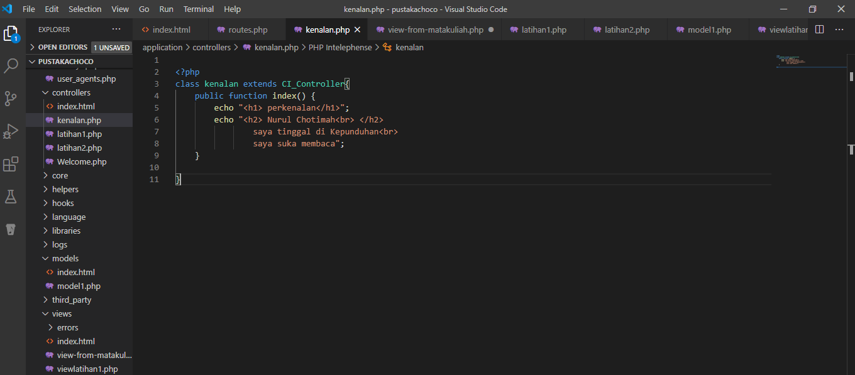

1. Hasil URL

<http://localhost/5/pustakachoco/index.php/kenalan>

1. Capture Hasil

